/ ***Using on delete with foreign key***  /

There are five options for ON DELETE that can apply to the FOREIGN KEY. These are called <referential actions>

* **ON DELETE CASCADE**: if a row of the referenced table is deleted, then all matching rows in the referencing table are deleted.
* **ON DELETE SET NULL**: if a row of the referenced table is deleted, then all referencing columns in all matching rows of the referencing table to be set to null.
* **ON DELETE SET DEFAULT**: if a row of the referenced table is deleted, then all referencing columns in all matching rows of the referencing table to be set to the column’s default value.
* **ON DELETE RESTRICT**: it is prohibited to delete a row of the referenced table if that row has any matching rows in the referencing table.
* **ON DELETE NO ACTION** **(the default)**: there is no referential delete action; the referential constraint only specifies a constraint check.

************************************************************

/*Connection String Command in web.config /*

<connectionStrings>

<add name="DefaultConnection"

connectionString="Data Source=(LocalDb)\MSSQLLocalDB;

AttachDbFilename=|DataDirectory|\JobDb.mdf;

Initial Catalog=JobDb;

Integrated Security=True;

MultipleActiveResultSets=True"

providerName="System.Data.SqlClient" />

</connectionStrings>

************************************************************

/ ***How do I add BundleConfig.cs to my project*** /

1-Install-Package Microsoft.AspNet.Web.Optimization

2-Add this in App_Start:

using System.Web.Optimization;

protected void Application_Start()

{

AreaRegistration.RegisterAllAreas();

RouteConfig.RegisterRoutes(RouteTable.Routes);

BundleConfig.RegisterBundles(BundleTable.Bundles);

}

************************************************************

/**Format your style in page** /

Ctrl+K+D

************************************************************

**Comment :**

Ctrl+K+C

************************************************************

**UnComment :**

Ctrl+K+U

************************************************************

/**How to reset (modal form) after save form** / $(".modal").on("hidden.bs.modal", function () {

$("#formId").trigger("reset");

});

Ex:

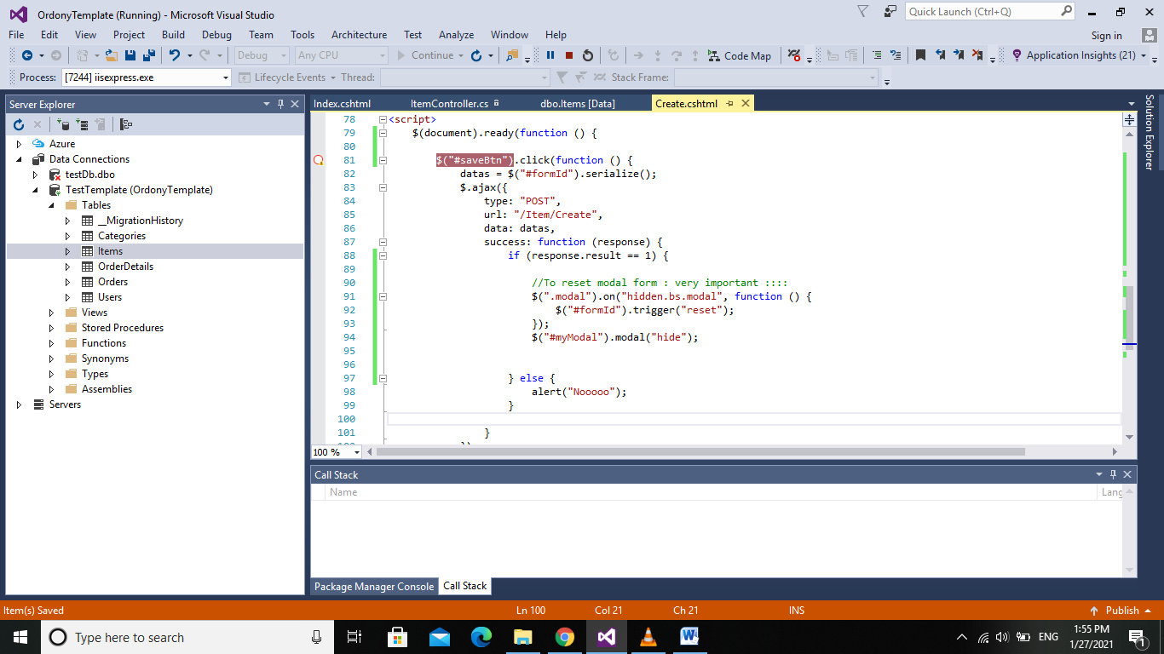

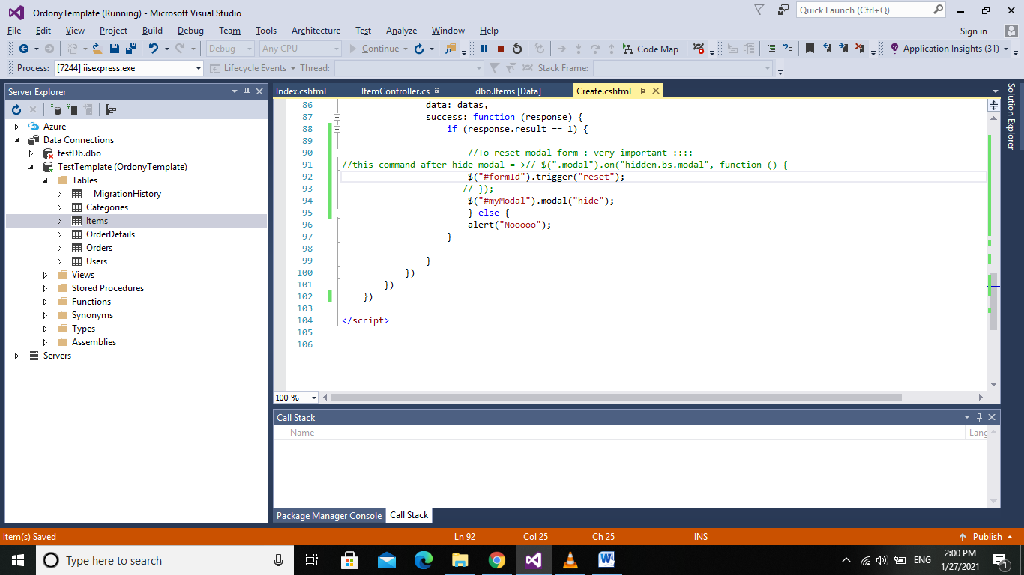

************************************************************

**/ To make close button in modal :** /

<a href="#" class="close" data-dismiss="modal">&times;</a>

OR :   
<button class="close" data-dismiss="modal">&times;</button>

Ex:

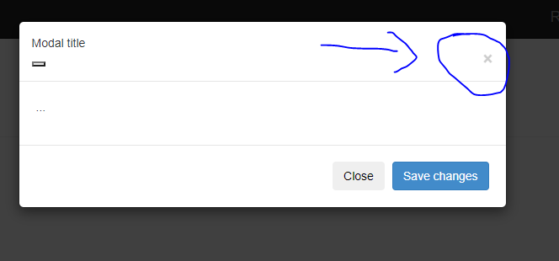

************************************************************

**/How to redirect to another page and pass id /**

var urls = '@Url.Action("Login", "Account", new { id = "__id__" })';

window.location.href = urls.replace('__id__', id);

**/How to redirect to another page without pass id /**

var urls = '@Url.Action("Login", "Account")';

Ex:

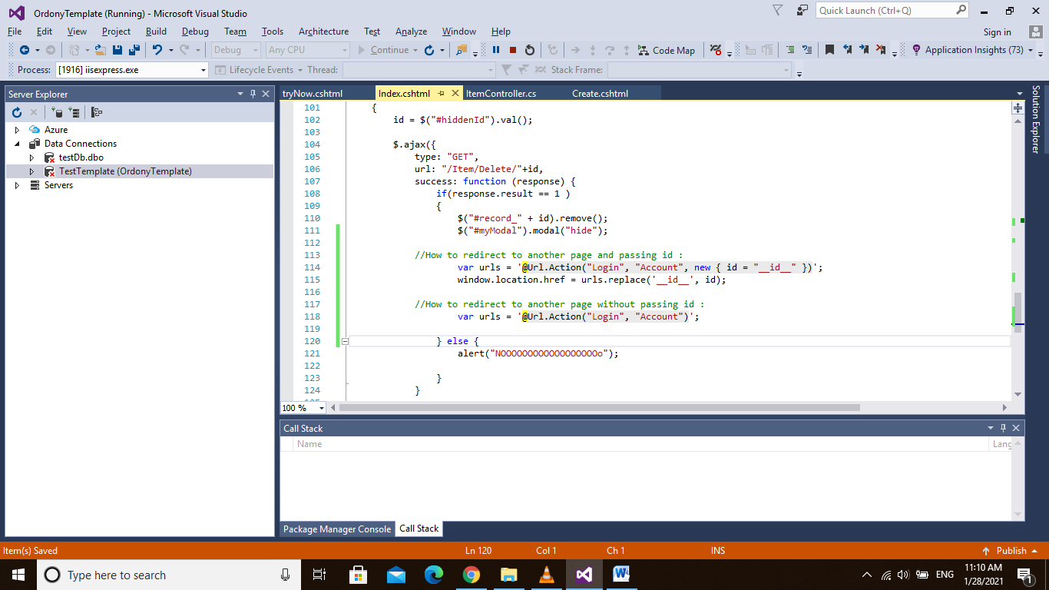

************************************************************

/ Two major things : /

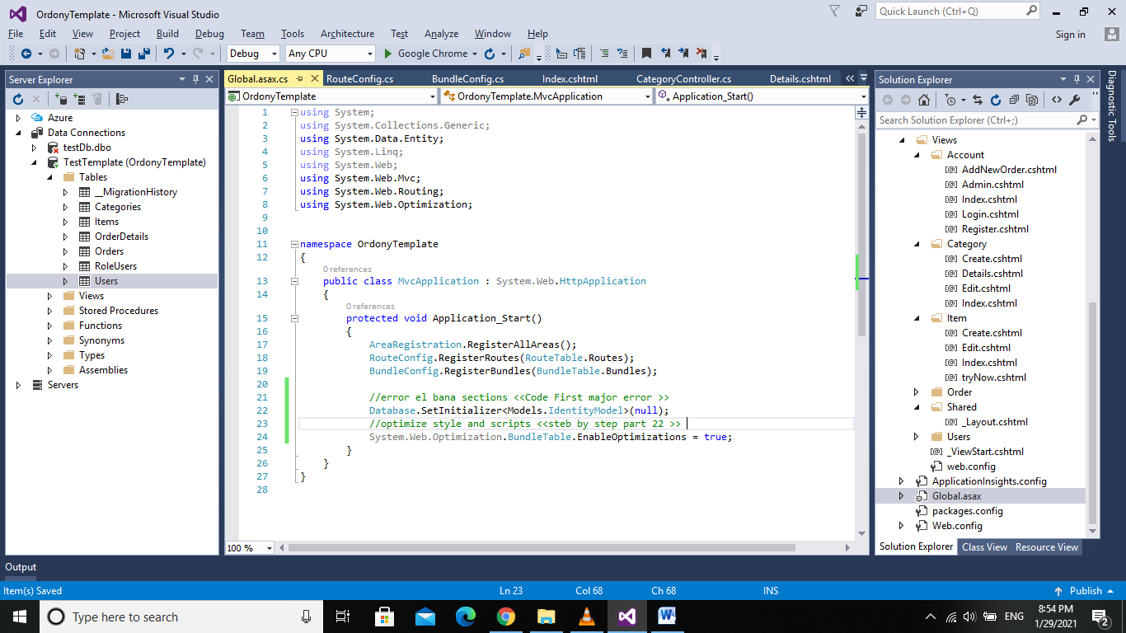  
…………………………………………

**Different between genres and movies**

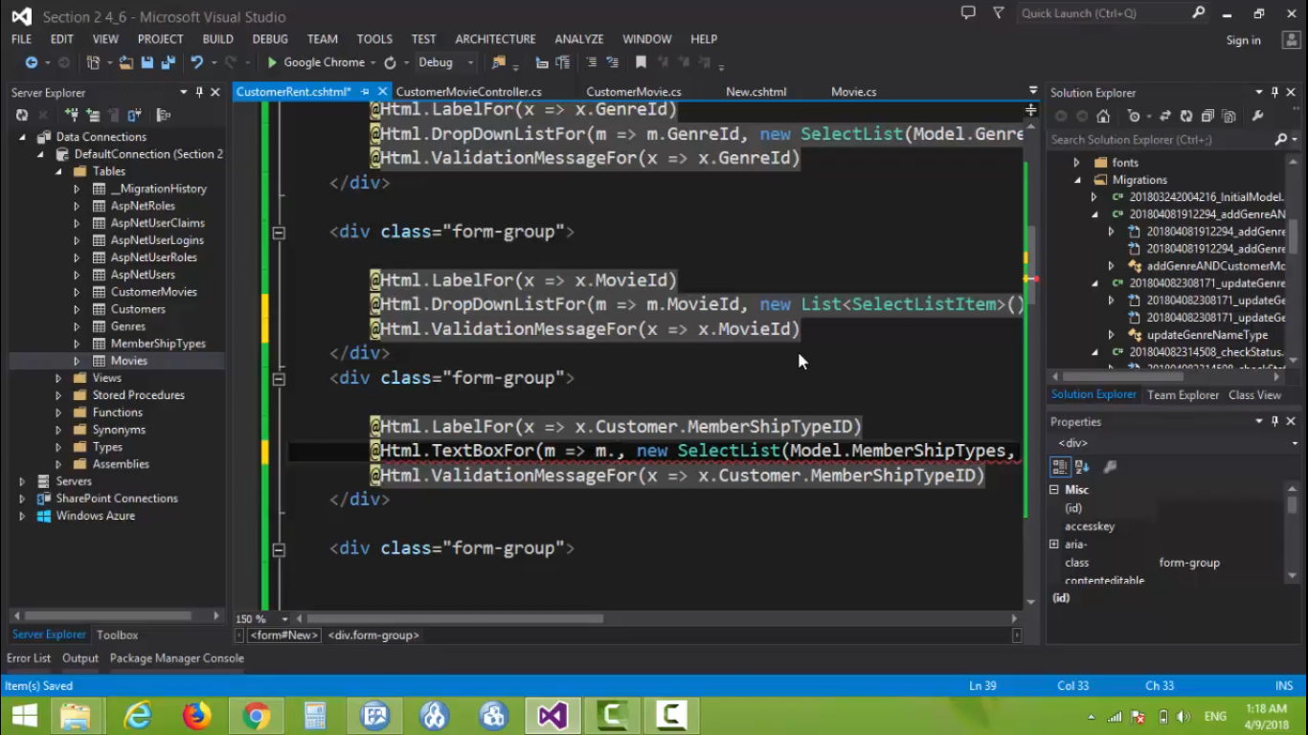

**Send Email:**

Solve error authentication 575:

https://stackoverflow.com/questions/20906077/gmail-error-the-smtp-server-requires-a-secure-connection-or-the-client-was-not